E-commerce Store For Artist

A Project Report Submitted

*in partial fulfillment for the award of the degree*

*of*

# Bachelor of Technology

in

# INFORMATION TECHNOLOGY

Aman Sharma (2004310130005) Submitted To:

Kanishk Mishra(2004310130010) Miss. Tripti Sahu

Aditya Kumar (2004310130004)

Umang Mishra (2004310130028)



**B.N COLLEGE OF ENGINEERING AND TECHNOLOGY, LUCKNOW**

**Affiliated**

# A.P. J. ABDUL KALAM TECHNICAL UNIVERSITY,

# LUCKNOW, INDIA

DECEMBER, 2022

**DECLARATION BY THE CANDIDATE**

I hereby declare that the Mini Project report entitled “TRADE ART**”** submitted by me to B.N. College Of Engineering And Technology, Lucknow in partial fulfillment of the requirement for the award of the degree of **Bachelor of Technology** in **Computer Science & Engineering** is a record of bonafide industrial training undertaken by me under the supervision of Miss. Tripti Sahu. I further declare that the work reported in this report has not been submitted and will not be submitted, either in part or in full, for the award of any other degree or diploma in this institute or any other institute or university.

Vellore: Signature of the Candidate

Date:

**BONAFIDE CERTIFICATE**

This is to certify that this project report entitled “TRADE ART” submitted to B. N College of Engineering and Technology, Lucknow, is a bonafide record of work done by this group under my supervision from “ ” to “ ” .

Signature of Supervisor

(Miss Tripti Sahu)

Place

Date

**Acknowledgement**

I would like to express my deep and sincere gratitude to my supervisor Miss. Tripti Sahu, who gave me h full support and encouraged me to work in an innovative and challenging project for Educational field. Her wide knowledge and logical thinking gave me right direction all the time. I am deeply grateful my project coordinator for his help and support provided at every step of the project.

PLACE : LUCKNOW Aman Sharma (2004310130005)

Kanishk Mishra(2004310130010)

Aditya Kumar (2004310130004)

Umang Mishra (2004310130028)

# TABLE OF CONTENTS

|  |  |  |  |
| --- | --- | --- | --- |
| **S.No.** | **TITLE** | **PAGE NO.** | **SIGNATURE** |
| **1.** | **Abstract** | 7 |  |
|  | 1.1 Scope of system | 7 |  |
| **2.** | **Chapter 1** |  |  |
|  | 2.1 Introduction | 8 |  |
|  | 2.1.1 What is E-Commerce | 8 |  |
|  | 2.1.2 Trade Art | 9 |  |
| **3**. | **Chapter 2** | 10 |  |
|  | 3.1 Technologies used in project | 10 |  |
|  | 3.1.1 HTML | 10 |  |
|  | 3.1.2 CSS | 11 |  |
|  | 3.1.3 JAVASCRIPT | 12 |  |
|  |  |  |  |
| **4** | **Chapter 3** | 13 |  |
|  | 4.1 Design of project Model | 13 |  |
|  | 4.1.1 Methodology and design | 14 |  |
|  | 4.1.2 Features | 15 |  |

|  |  |  |  |
| --- | --- | --- | --- |
| **CHAPTER NO.** | **TITLE** | **PAGE NO.** | **SIGNATURE** |
| **5.** | **Chapter 4** | 16 |  |
|  | 5.1 Result and conclusion | 16 |  |
|  | 5.1.1 Result | 17 |  |
|  | 5.1.2 Conclusion | 17 |  |
|  | 5.2 References | 18 |  |
|  |  |  |  |
|  |  |  |  |
|  |  |  |  |

**ABSTRACT**

E-commerce (electronic commerce) is the buying and selling of goods and services, or the transmitting of funds or data, over an electronic network, primarily the internet. These business transactions occur either as business-to-business ([B2B](https://www.techtarget.com/searchcio/definition/B2B)), business-to-consumer ([B2C](https://www.techtarget.com/searchcustomerexperience/definition/B2C)), consumer-to-consumer or consumer-to-business.

The terms e-commerce and e-business are often used interchangeably. The term e-tail is also sometimes used in reference to the [transactional processes](https://www.techtarget.com/searchcio/definition/transaction) that make up online retail shopping.

In the last two decades, widespread use of e-commerce platforms such as Amazon and eBay has contributed to substantial growth in online retail. In 2011, e-commerce accounted for 5% of total retail sales, according to the U.S. Census Bureau. By 2020, with the start of the COVID-19 pandemic, it had risen to over 16% of retail sales.

SCOPE OF THE SYSTEM

The main scope is to support artist on a global level and spread love for art and help artist to make a professional career in art. To establish a community where artist and one who loves to buy art can meet at same place and a connection can be made. Trade Art is a community instead of just a simple web store.

**CHAPTER-1**

**INTRODUCTION**

**What is E-COMMERCE?**

## Definition and Classification

E-commerce (electronic commerce) is the buying and selling of goods and services, or the transmitting of funds or data, over an electronic network, primarily the internet. These business transactions occur either as business-to-business ([B2B](https://www.techtarget.com/searchcio/definition/B2B)), business-to-consumer ([B2C](https://www.techtarget.com/searchcustomerexperience/definition/B2C)), consumer-to-consumer or consumer-to-business.

The terms e-commerce and e-business are often used interchangeably. The term e-tail is also sometimes used in reference to the [transactional processes](https://www.techtarget.com/searchcio/definition/transaction) that make up online retail shopping.

In the last two decades, widespread use of e-commerce platforms such as Amazon and eBay has contributed to substantial growth in online retail. In 2011, e-commerce accounted for 5% of total retail sales, according to the U.S. Census Bureau. By 2020, with the start of the COVID-19 pandemic, it had risen to over 16% of retail sales.

### How does e-commerce work?

E-commerce is powered by the internet. Customers access an online store to browse through and place orders for products or services via their own devices.

As the order is placed, the customer's web [browser](https://www.techtarget.com/whatis/definition/browser) will communicate back and forth with the [server](https://www.techtarget.com/whatis/definition/server) hosting the e-commerce website. Data pertaining to the order will be relayed to a central computer known as the [order manager](https://www.techtarget.com/searcherp/definition/order-management). It will then be forwarded to databases that manage inventory levels; a merchant system that manages payment information, using applications such as PayPal; and a bank computer. Finally, it will circle back to the order manager. This is to make sure that store inventory and customer funds are sufficient for the order to be processed.

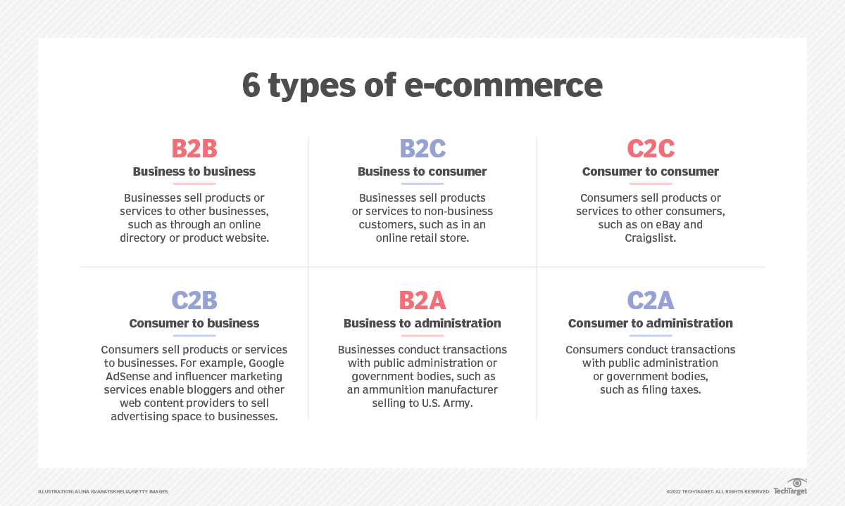

**TRADEART**

Trade Art is social platform for artist to publish share and discuss art & artworks. It's a free platform so you can register using your email address.

Art community and Art Store is curated by a artists themselves to keep up the community standards and make the platform safe enough for everyone by following community guidelines.

Our website encourages artists to join together and support other artist through different platforms and other activities. We intend to support artist around the globe by organizing events and offering a platform to sell there artwork.

**CHAPTER-2**

**Technologies Used in Project**

HTML

HTML is an acronym which stands for **Hyper Text Markup Language** which is used for creating web pages and web applications. Let's see what is meant by Hypertext Markup Language, and Web page.

**Hyper Text:** HyperText simply means "Text within Text." A text has a link within it, is a hypertext. Whenever you click on a link which brings you to a new webpage, you have clicked on a hypertext. HyperText is a way to link two or more web pages (HTML documents) with each other.

**Markup language:** A markup language is a computer language that is used to apply layout and formatting conventions to a text document. Markup language makes text more interactive and dynamic. It can turn text into images, tables, links, etc.

**Web Page:** A web page is a document which is commonly written in HTML and translated by a web browser. A web page can be identified by entering an URL. A Web page can be of the static or dynamic type. **With the help of HTML only, we can create static web pages**.

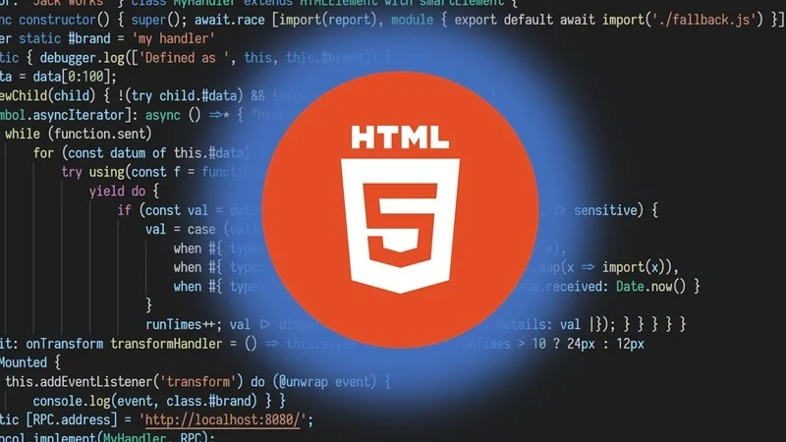

CSS

CSS stands for Cascading Style Sheets. It is a style sheet language which is used to describe the look and formatting of a document written in markup language. It provides an additional feature to HTML. It is generally used with HTML to change the style of web pages and user interfaces. It can also be used with any kind of XML documents including plain XML, SVG and XUL.

CSS is used along with HTML and JavaScript in most websites to create user interfaces for web applications and user interfaces for many mobile applications.

What does CSS do?

* You can add new looks to your old HTML documents.
* You can completely change the look of your website with only a few changes in CSS code.

Why use CSS ?

* Solves problem of styling elements one by one.
* Saves a lot of time.
* Can add more additional features.

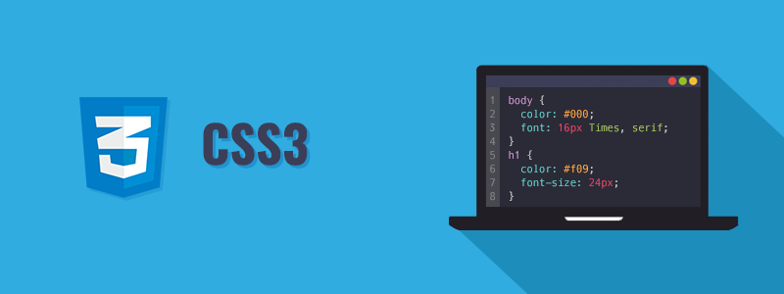

JAVASCRIPT

JavaScript (js) is a light-weight object-oriented programming language which is used by several websites for scripting the webpages. It is an interpreted, full-fledged programming language that enables dynamic interactivity on websites when applied to an HTML document. It was introduced in the year 1995 for adding programs to the webpages in the Netscape Navigator browser. Since then, it has been adopted by all other graphical web browsers. With JavaScript, users can build modern web applications to interact directly without reloading the page every time. The traditional website uses js to provide several forms of interactivity and simplicity.

Although, JavaScript has no connectivity with Java programming language. The name was suggested and provided in the times when Java was gaining popularity in the market. In addition to web browsers, databases such as CouchDB and MongoDB uses JavaScript as their scripting and query language.

Why JAVASCRIPT?

1. All popular web browsers support JavaScript as they provide built-in execution environments.
2. JavaScript follows the syntax and structure of the C programming language. Thus, it is a structured programming language.
3. JavaScript is a weakly typed language, where certain types are implicitly cast (depending on the operation).
4. JavaScript is an object-oriented programming language that uses prototypes rather than using classes for inheritance.
5. It is a light-weighted and interpreted language.

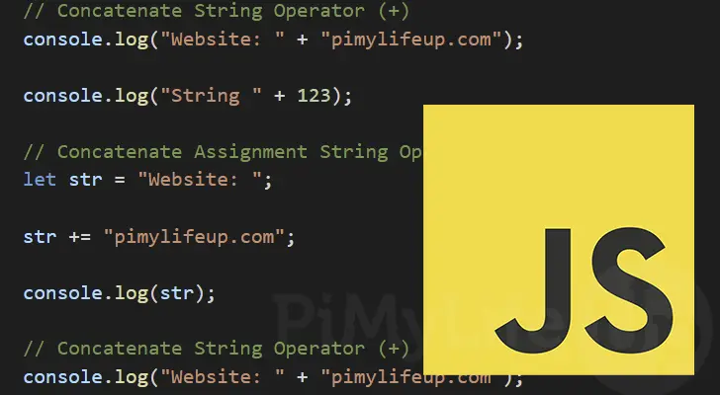

**CHAPTER-3**

Design and Methodology

In order to design and developing TradeArt, few related works have been reviewed. The related works are summarized as in:

We searched for many E-commerce websites that sell paintings but that’s what they are a shop.

For Example:

Any Shopify Store, E-BAY, Amazon, Flipkart etc.

A significant proportion of the art market belongs to the ₹ 0.1-0.5 million segment and a tax rate of 12% on this is substantial enough to discourage buyers.

We also researched about the rapid decrease in artist rate in India and the number of artist are decreasing day by day as everyone has to make some living in the end. Getting their paintings auctioned was a lot of work and artist have to pay certain amount of fees to be part ofof these auctions.

Here Comes Our initiative Trade Art.

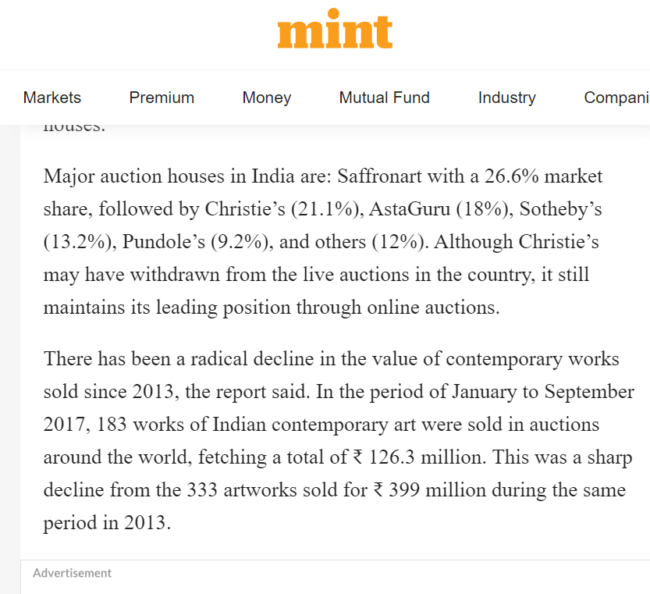

Methodology.

This research adopts the steps of waterfall model which progress from one phase to another linearly, as illustrated in Figure.

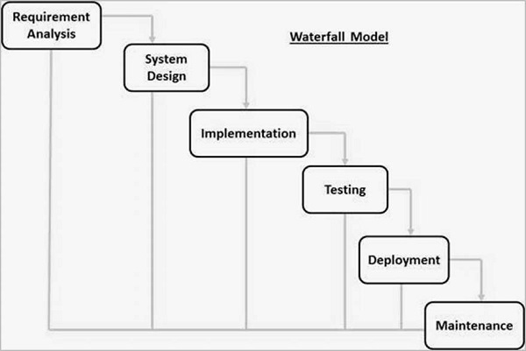

DESIGN

TradeArt is designed very simply so artist can easily take advantage of the simple design and use our website for there benefit.

We used user friendly UI methods in developing our website and made it more simplified so that any one can get connected to us in no time.

Buyers, Sellers or even locals who love collecting or simply love ART. 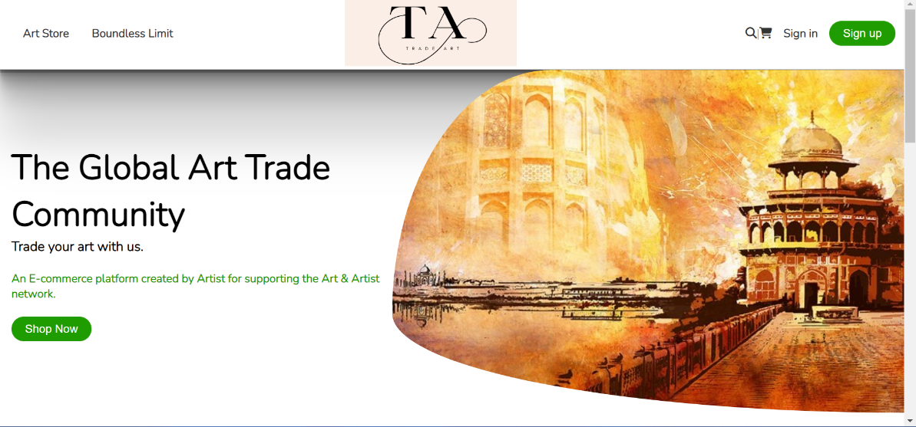

THE HOME PAGE

**CHAPTER-4**

**Result and conclusion**

Result of all the research and hard work, and analysis the below figure shows our website TRADEART and the ARTSTORE residing in it.

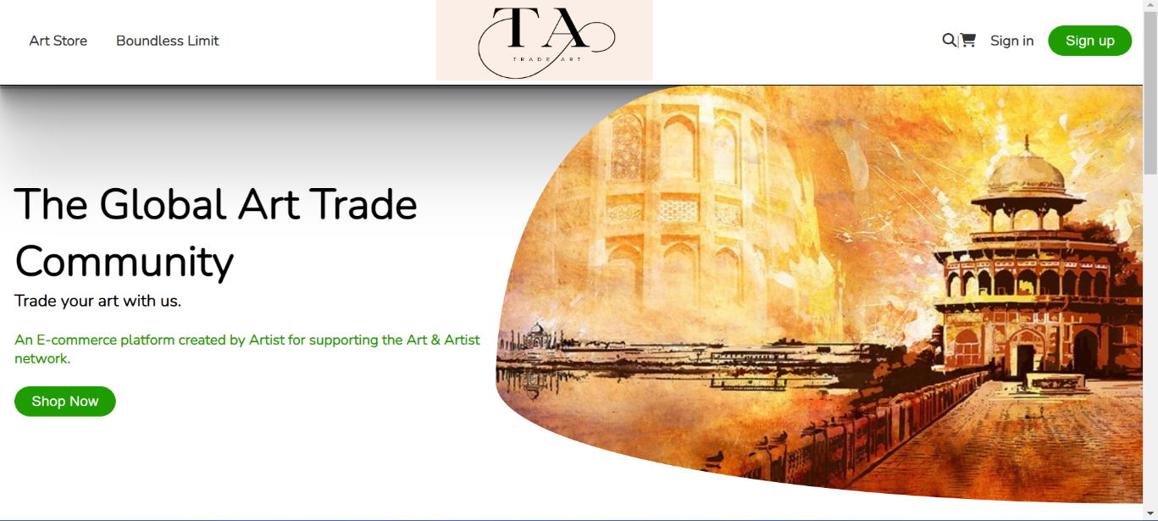

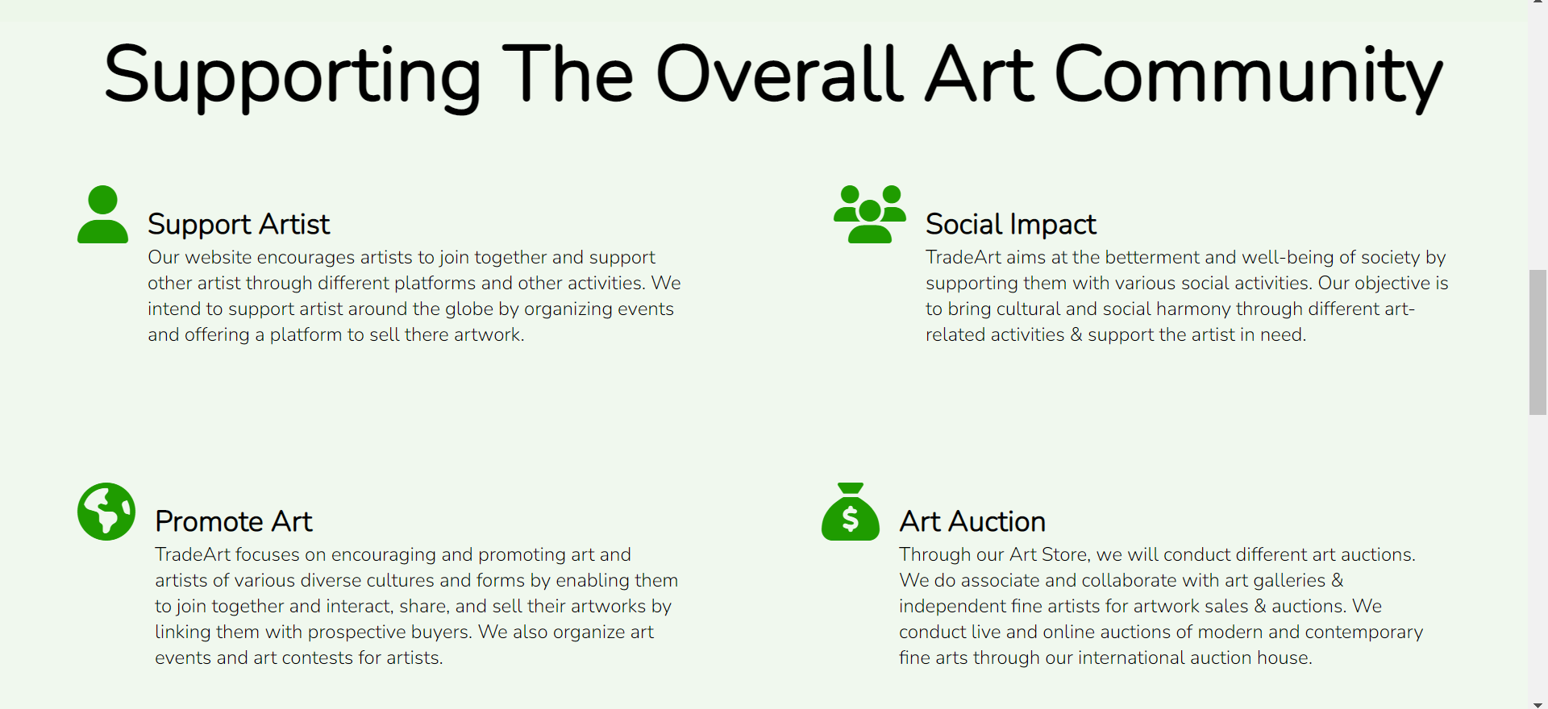

TRADEART

The artist can upload their paintings and artwork and buyers can buy them online by placing orders from there own devices. The buyer will be verified through there given credentials and mobile number and then they can get their artwork delivered to there respective addresses.

TRADEART does not charge any fee on creating an account anyone can simply create and sign up using there email addresses and can start buying immediately once their address is verified.

The given address for delivery should be in range of delivery are of TRADEART.

TRADEART does not take any money in between as the buyer directly pays to artist and there is complete transparency in the prices and transactions.

Conclusion

TRADEART is a great initiative for the upcoming era in which life is getting digital but our beloved artists are getting left behind. TRADEART is an initiative that can bring lots of artist and art lovers together and can create a beautiful community just for the cause of art.

FUTURE SCOPE OF TRADEART: We are going to digitalize some of the art works of artists into an NFT (Non Fungible Tokens). So that they can earn more from the work they created. As NFT is rapidly growing globally artist can also get advantage of that.

**References**

The following books were referred during the analysis and execution phase of the project:

1. Code with Random

2. W3Schools.com

3. livemint.com

4.Artsy.com

5.JavaTpoint.